**Project Design Phase-II**

**Technology Stack (Architecture & Stack)**

**Technical Architecture:**

The Deliverable shall include the architectural diagram as below and the information as per the table1 & table 2

**Example: Order processing during pandemics for offline mode**

**Reference:** [**https://developer.ibm.com/patterns/ai-powered-backend-system-for-order-processing-during-pandemics/**](https://developer.ibm.com/patterns/ai-powered-backend-system-for-order-processing-during-pandemics/)

Guidelines:

1. Include all the processes (As an application logic / Technology Block)
2. Provide infrastructural demarcation (Local / Cloud)
3. Indicate external interfaces (third party API’s etc.)
4. Indicate Data Storage components / services
5. Indicate interface to machine learning models (if applicable)

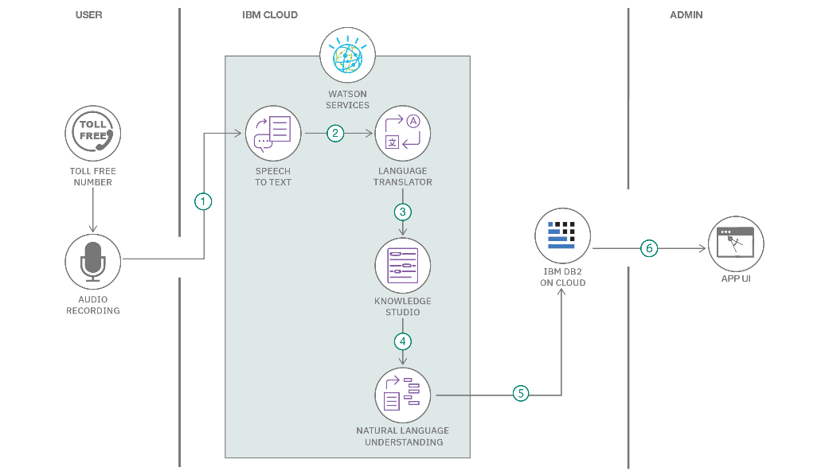

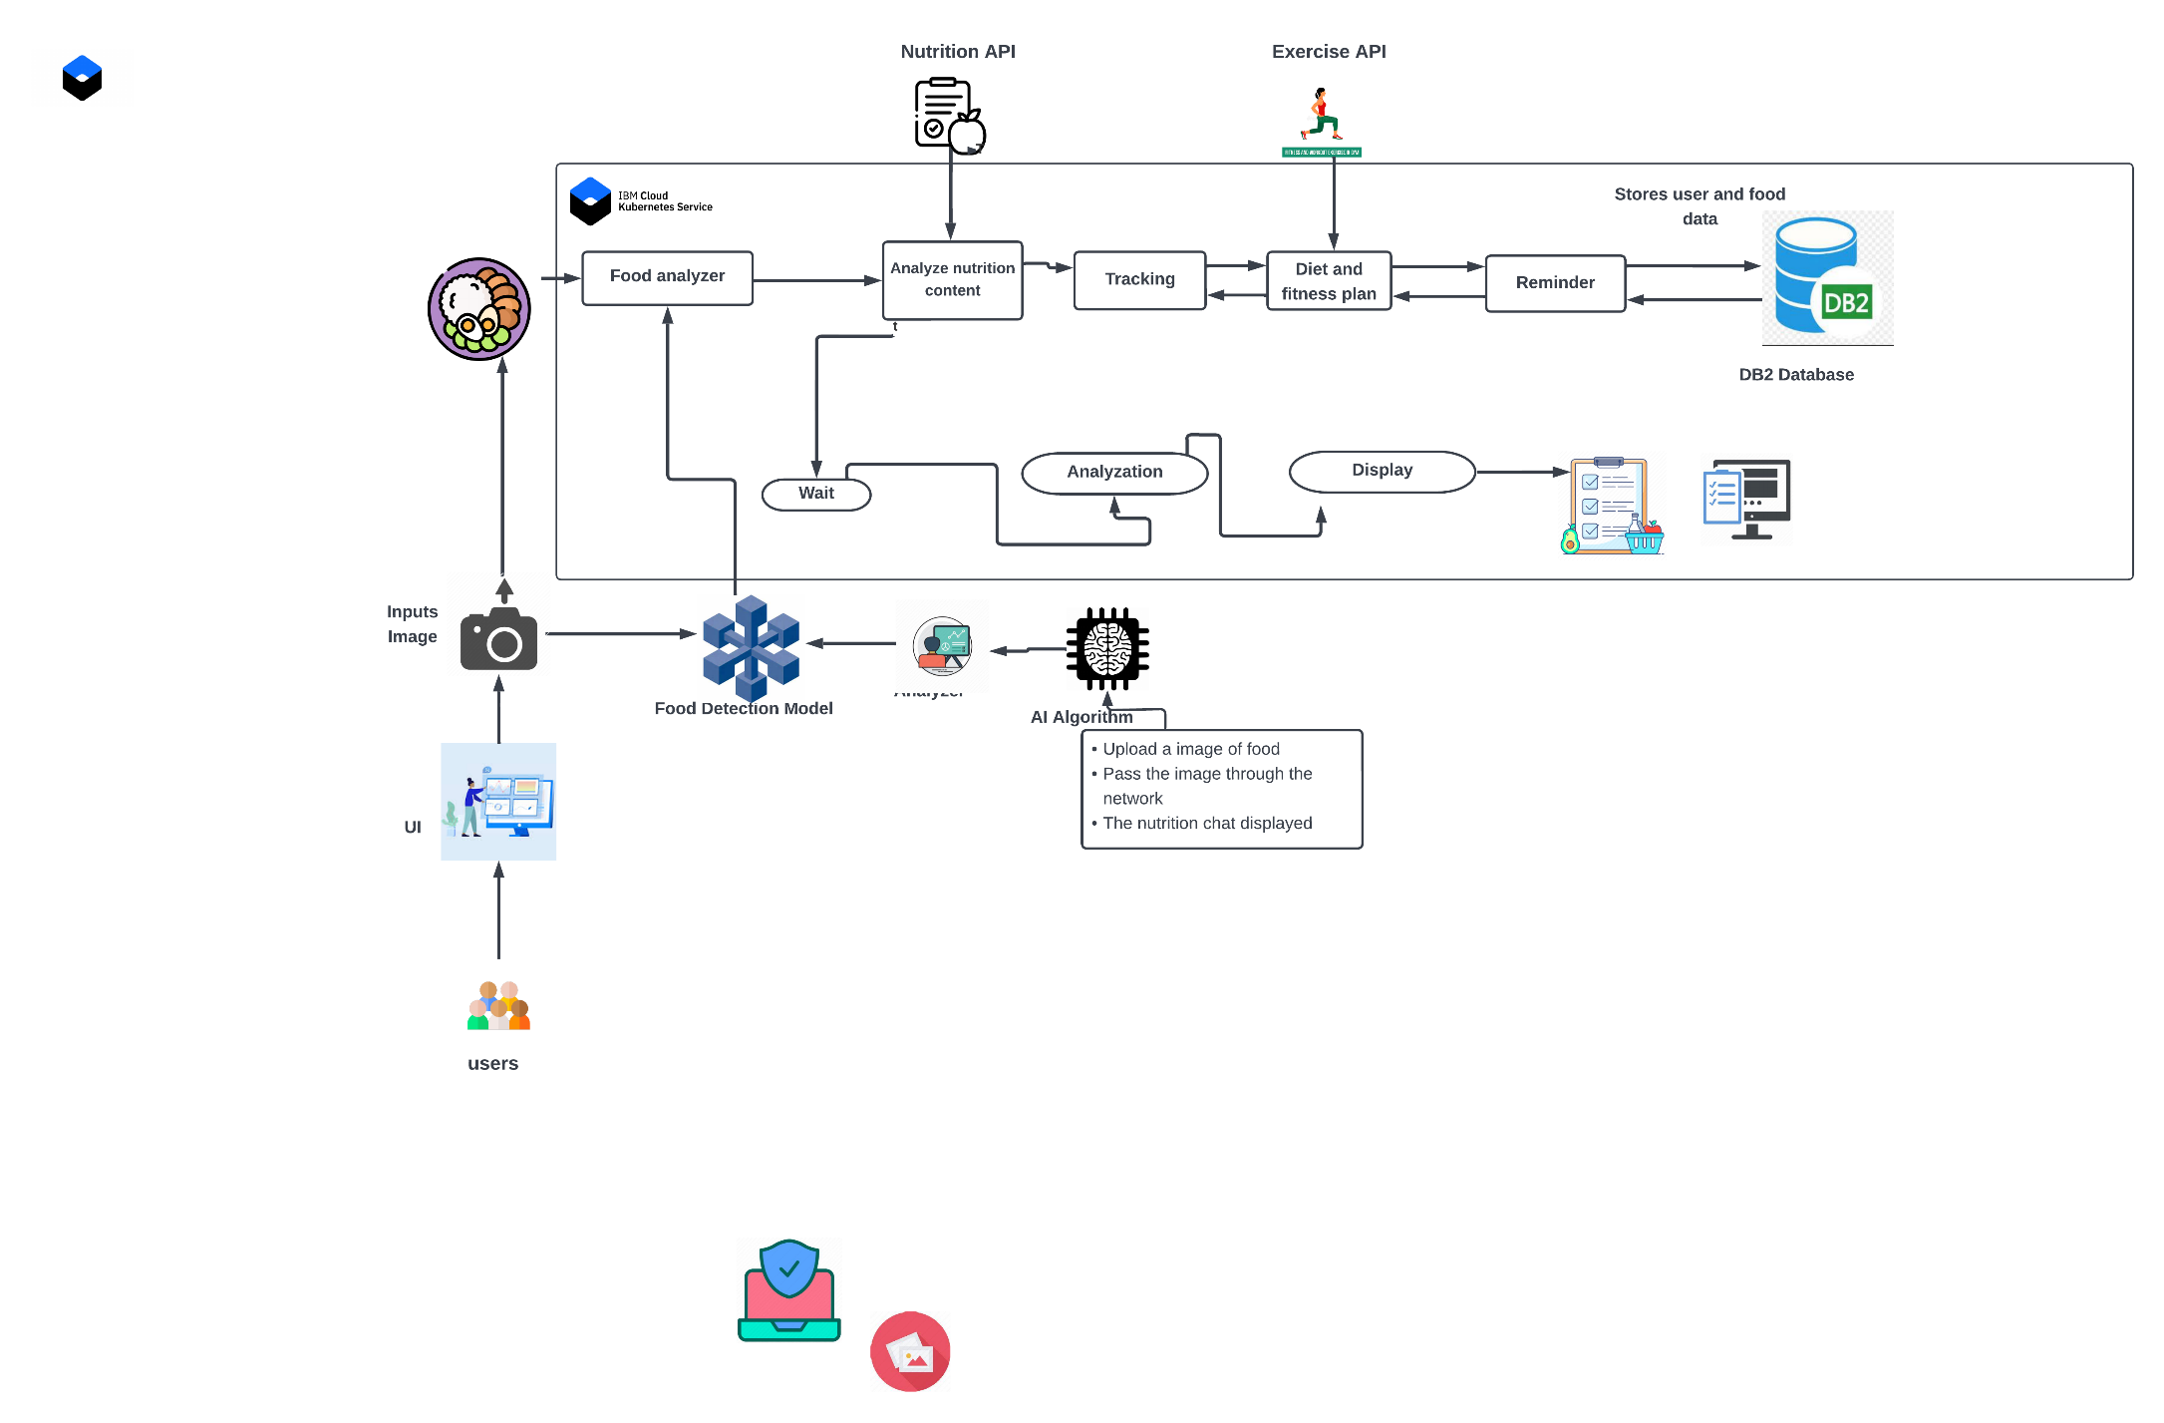

**Table-1 : Components & Technologies:**

|  |  |  |  |
| --- | --- | --- | --- |
| **S.No** | **Component** | **Description** | **Technology** |
|  | User Interface | The registered user interacts using Web UI, and Chatbot. | HTML, CSS, JavaScript |
|  | Application Logic-1 | To create a functional unit that performs dashboard functions | Python |
|  | Application Logic-2 | To create a | Python |
|  | Application Logic-3 | To easy understanding and resolve user query | IBM Watson Assistant |
|  | Cloud Database | Database Service on Cloud | IBM DB2. |
|  | File Storage | File storage requirements | IBM Object Storage |
|  | External API-1 | Exercises API provide thousands of exercises targeting every major muscle group. | Exercises API |
|  | External API-2 | Food API gives the nutrition content analyzed from image | Recipe-Food-Nutrition API |
|  | Machine Learning Model | Food Detection Model helps to detect food from input image. | Clarifai’s AI-Driven Food detection Model. |
|  | Infrastructure (Server / Cloud) | Application Deployment on Local System / Cloud  Local Server Configuration:  Cloud Server Configuration : | IBM Container registry, Cloud Foundry, Kubernetes,Docker etc. |

**Table-2: Application Characteristics:**

| **S.No** | **Characteristics** | **Description** | **Technology** |
| --- | --- | --- | --- |
|  | Open-Source Frameworks | Flask is used to build and manage web applications | Flask |
|  | Security Implementations | [Web application firewall](https://www.cloudflare.com/learning/ddos/glossary/web-application-firewall-waf/) (WAF) helps protect a web application against malicious [HTTP](https://www.cloudflare.com/learning/ddos/glossary/hypertext-transfer-protocol-http/) traffic  The Open Web Application Security Project (OWASP).  Asymmetric algorithms is implemented using public key cryptography is certificates. | OWASP,WAF,Asymmetric algorithms |
|  | Scalable Architecture | Microservices Architecture framework permits developers to roll out applications faster and with greater efficiency. | IBM Kubernetes |
|  | Availability | Cloud service is used to achieve high availability  Traefik is the leading open source cloud-native load balancer and ingress controller for HTTP and TCP-based applications. | IBM Cloud foundry, Traefik . |
|  | Performance | [Nagios](https://www.nagios.org/) helps to completely monitoring systems related to web app performance . | [Nagios](https://www.nagios.org/) |

**References:**

[**https://c4model.com/**](https://c4model.com/)

[**https://developer.ibm.com/patterns/online-order-processing-system-during-pandemic/**](https://developer.ibm.com/patterns/online-order-processing-system-during-pandemic/)

[**https://www.ibm.com/cloud/architecture**](https://www.ibm.com/cloud/architecture)

[**https://aws.amazon.com/architecture**](https://aws.amazon.com/architecture)

[**https://medium.com/the-internal-startup/how-to-draw-useful-technical-architecture-diagrams-2d20c9fda90d**](https://medium.com/the-internal-startup/how-to-draw-useful-technical-architecture-diagrams-2d20c9fda90d)